Contents
INTRODUCTION: ASSEMBLY LANGUAGE X86 TOPICS 2
ASCII BASICS 9
UNICODE: THE WORLD’S TEXT SYSTEM 10

INTRODUCTION: ASSEMBLY LANGUAGE X86 TOPICS
Basic Concepts: Applications of assembly language, basic concepts, machine language, and data representation.
x86 Processor Architecture: Basic microcomputer design, instruction execution cycle, x86 processor architecture, Intel64 architecture, x86 memory management, components of a microcomputer, and the input–output system.
Assembly Language Fundamentals: Introduction to assembly language, linking and debugging, and defining constants and variables.
Data Transfers, Addressing, and Arithmetic: Simple data transfer and arithmetic instructions, assemble-link-execute cycle, operators, directives, expressions, JMP and LOOP instructions, and indirect addressing.
Procedures: Linking to an external library, description of the book’s link library, stack operations, defining and using procedures, flowcharts, and top-down structured design.
Conditional Processing: Boolean and comparison instructions, conditional jumps and loops, high- level logic structures, and finite-state machines.
Integer Arithmetic: Shift and rotate instructions with useful applications, multiplication and division, extended addition and subtraction, and ASCII and packed decimal arithmetic.
Advanced Procedures: Stack parameters, local variables, advanced PROC and INVOKE directives, and 2/31 recursion.
Strings and Arrays: String primitives, manipulating arrays of characters and integers, two- dimensional arrays, sorting, and searching.
Structures and Macros: Structures, macros, conditional assembly directives, and defining repeat blocks.
MS-Windows Programming: Protected mode memory management concepts, using the Microsoft-Windows API to display text and colors, and dynamic memory allocation.
Floating-Point Processing and Instruction Encoding: Floating-point binary representa- tion and floating-point arithmetic. Learning to program the IA-32 floating-point unit. Under- standing the encoding of IA-32 machine instructions.
High-Level Language Interface: Parameter passing conventions, inline assembly code, and linking assembly language modules to C and C++ programs.
16-Bit MS-DOS Programming: Memory organization, interrupts, function calls, and stan- dard MS- DOS file I/O services.

Disk Fundamentals: Disk storage systems, sectors, clusters, directories, file allocation tables, handling MS-DOS error codes, and drive and directory manipulation.
BIOS-Level Programming: Keyboard input, video text, graphics, and mouse programming.
Expert MS-DOS Programming: Custom-designed segments, runtime program structure, and Interrupt handling. Hardware control using I/O ports.

ASCII Control Characters: Mnemonics & Labels
What they are
ASCII control characters are non-printable characters.
They do not show text on the screen.
Why they exist
They are used to control devices, not display letters.
Examples: screen, keyboard, printer, serial port.
How they work
- Generated by pressing combinations like Ctrl + C, Ctrl + G
- Sent as numeric values, not visible symbols
- The receiving device interprets them as commands
What they control
They are commonly used to:
- Move the cursor
- Start a new line
- Make a beep sound
- Reset positions in terminals or printers
Common examples
- LF (Line Feed) – move down one line
- CR (Carriage Return) – move cursor to start of line
- BEL (Bell) – beep sound
- ESC (Escape) – start control sequences

Representation
Each control character has:
- A mnemonic (e.g. BEL, CR, ESC)
- A numeric value (usually hex, e.g. 07h, 0Dh, 1Bh)
- A defined behavior
Important note
These are not magic and not special to assembly.
They are just agreed-upon signals that software and hardware understand.
Find the ASCII.html OR ASCII.png attached for the full table.

🤖 Why do mnemonics matter?
Why do mnemonics matter? 🤖
Mnemonics are like nicknames.
Instead of remembering what 1Bh means, you use ESC.
This makes code easy to read and easier for your brain to understand.
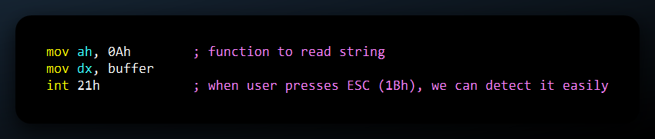
Mnemonics are like street names.
Hex codes are like GPS numbers.
Both go to the same place, but street names are easier for people.

❗ Ctrl + Hyphen (–)
Yes, Ctrl + – makes ASCII 1Fh.
It is a real control character.
People don’t use it much, but it exists in the official ASCII list.

🔤 ALT Key Combinations
When you hold ALT and press a number or letter, the keyboard makes a special character.
These are used to:
- Make keyboard shortcuts
- Type special symbols (©, █, ü, etc.)
- Work with other languages or old programs
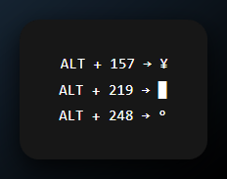
🛠️ Why they mattered (and still matter):
In old DOS and early Windows programs, people used them to:
- Draw text screens (like ALT + 219 for blocks)
- Read keyboard input with ALT codes
- Make custom keyboard shortcuts
Today, modern apps don’t use them much,
but they still work in BIOS, command line, and low-level programs.
Find the AltKeyCombinations.html OR AltKeyCombinations.png for the full table.

🧱 Keyboard Scan Codes vs ASCII vs ALT Keys
(Know what your keyboard is really sending.)

1. Keyboard Scan Codes – Hardware Level
When you press a key (like A), the keyboard does not send the letter A.
It sends a scan code, which is a basic signal.
It is like saying: “Someone pressed this key spot on the keyboard.”
These codes are numbers like 1Eh for the A key.
The BIOS or operating system uses them to find out which key was pressed.
Scan codes are about key position, not the letter you see on the screen.
🛠️ Example:
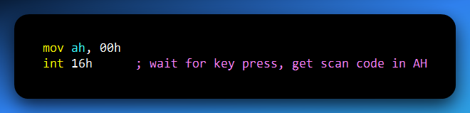
Find the KeyboardScanCodes.html OR KeyboardScanCodes.png for the full table.

🧩2. Why this Matters (for ASM or Reverse Engineering)
Keyboard input is not always ASCII
- BIOS keyboard services (int 16h) return scan codes
- Scan codes tell you which key was pressed, not which character
- This matters for:
  - Function keys
  - Arrow keys
  - Key combinations

ASCII is for characters, not keys
- ASCII is used when working with text
- Examples:
  - Printing characters to the screen
  - Parsing input strings
  - Comparing text values
- ASCII does not represent physical keys
ALT combinations
- ALT key combinations can generate specific ASCII values
- Common in:
  - Old DOS programs
  - Terminal-style user interfaces
  - Custom input handling
- Useful when you want:
  - Non-standard characters
  - Direct control over input values
Reverse engineering relevance
- Programs may mix scan codes and ASCII
- Malware and old software often read raw keyboard input
- Understanding the difference helps you:
  - Read input-handling code correctly
  - Avoid misinterpreting key logic
Key Rule to Remember
Scan codes = physical keys
ASCII = characters
If you remember only that, you won’t get lost.
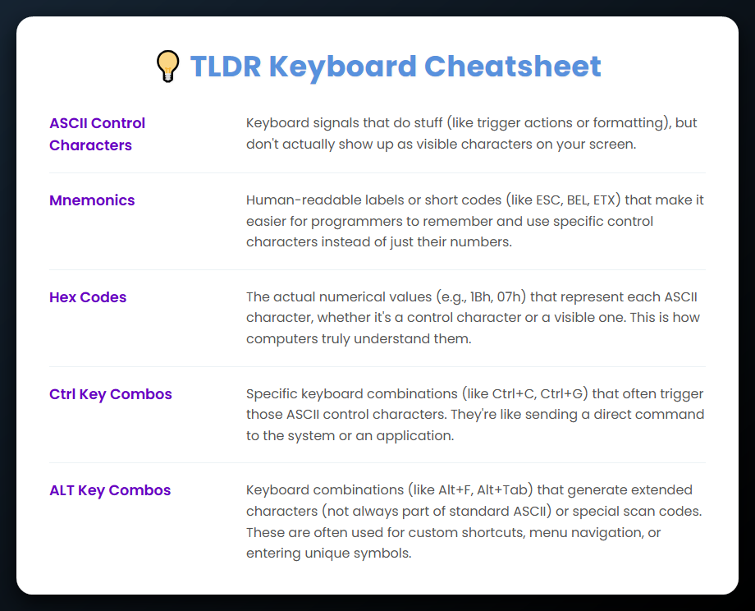
How Programming Languages Understand ASCII
💡 What is ASCII and why is it important?
ASCII is a system that gives letters and symbols a number.
For example:
- A = 65
- ! = 33
- 3 = 51
Computers only understand numbers (1s and 0s).
ASCII lets computers save and show text in a way people understand.

🧬 Character Encoding = Translation
Computers do not know what a letter is.
They only know numbers.
Character encoding is a translation system:
- You press A
- The keyboard sends a scan code
- The system turns it into ASCII 65
- The computer stores it as 01000001 (binary)
This lets:
- Programming languages work with text
- Operating systems show letters on the screen
- Programs save readable text in files

ASCII BASICS
ASCII uses 7 bits, which allows 128 characters total.
- 0–31 → Control characters
- 32–126 → Printable characters
- 127 → Delete (DEL)

🔧 1. Control Characters
These do not show on the screen. They control how text works.
Examples:
- LF (10) → New line
- CR (13) → Go to start of line
- TAB (9) → Tab space
- BEL (7) → Beep sound
- DEL (127) → Delete
These were very important in early computers.
🔤 2. Printable Characters
These are the characters you can see:
- Letters (A–Z, a–z)
- Numbers (0–9)
- Punctuation (?, ., ,)
- Symbols (@, #, $, %)

🧮 Binary and Hex
- ASCII numbers are often written in decimal (65)
- Inside the computer, they are binary (01000001)
- Programmers often use hex (41h) because it is shorter
Binary, decimal, and hex all mean the same value —
they are just different ways to write the number.

UNICODE: THE WORLD’S TEXT SYSTEM
ASCII only has 128 characters.
That works for English, but not for other languages or emojis.
Unicode fixes this.
It supports:
- All languages
- Emojis 🙂
- Math symbols
- Rare and old scripts
Unicode includes ASCII as the first 128 characters,
so ASCII is part of Unicode.

🤔 What is Unicode?
Unicode is the modern system computers use to store text.
It works for every language and symbol in the world.
Unicode:
- Has over 144,000 characters (and growing)
- Supports more than 150 writing systems
- Includes emojis and special symbols
- Is used in websites, apps, and operating systems
It exists because ASCII was too limited.

📦 Fixed vs Variable Length Encoding
🔹 ASCII (Fixed Size)
- Uses 7 bits per character
- Takes 1 byte for each character
- Can only show 128 characters
- Mostly English only
If you want, I can also simplify the UTF-8 / UTF-16 part next.

🔹 Unicode: Variable-Length
Unicode supports multiple encodings depending on the use case (See the UTF.html):
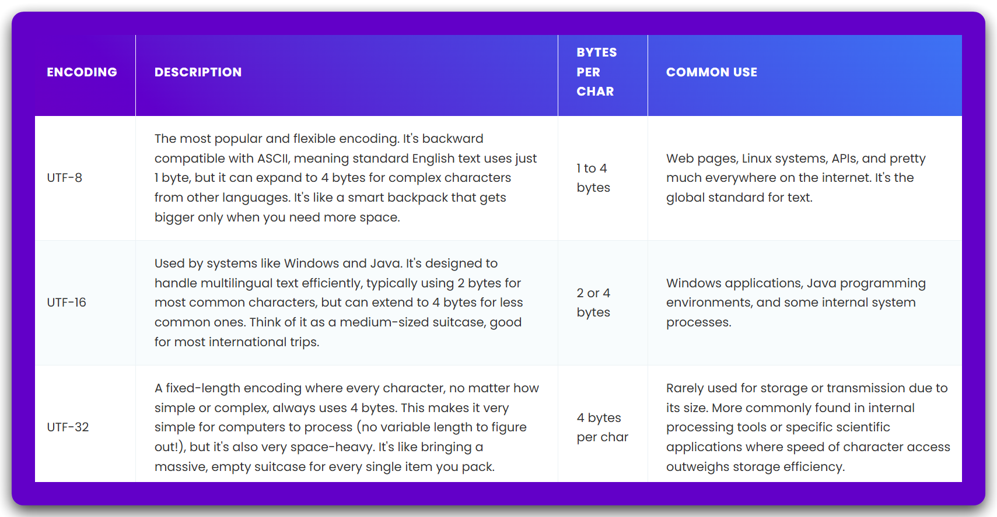
⚠️ UTF-8 is the king. It’s compact, fast, compatible, and everywhere — from HTML files to JSON to APIs.

💬 ASCII vs Unicode: Key Differences
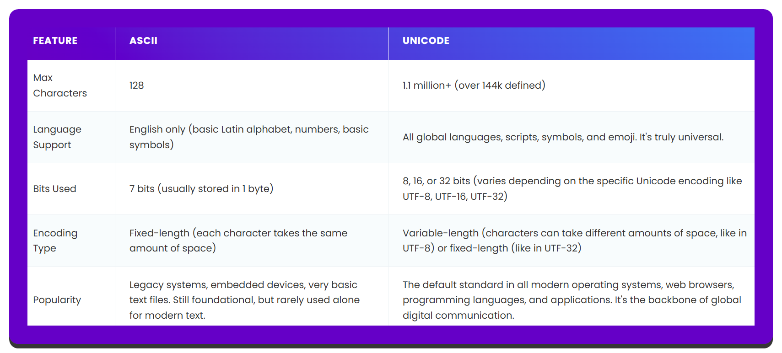

🧩 From Text to Machine Code
Step 1: Tokenization (Lexical Analysis)
When you write code, the computer does not understand it right away. First, it splits the code into small pieces called tokens. This step is called lexical analysis.
Think of it like this: A sentence is broken into words so it can be read. Code is broken into tokens so the computer can understand it. Tokens can be things like:
- Keywords
- Names
- Numbers
- Symbols
Example code:
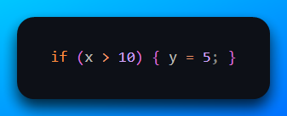
This gets broken down into tokens like:
- if → keyword
- ( → punctuation
- x → identifier
- > → operator
- 10 → constant
- { → block opener
- y → identifier
- = → operator
- 5 → constant
- ;, } → punctuation
🔎 Analogy: It’s like chopping a sentence into “The”, “quick”, “brown”, “fox”… so it’s easier to parse.
⚙️ Step 2: Compilation or Interpretation
After the code is broken into tokens,
the next step is to turn it into something the computer can run.
What happens next depends on the language:
- Compiled languages turn the code into a program first
- Interpreted languages run the code step by step
Either way, the computer is getting ready to execute your code.
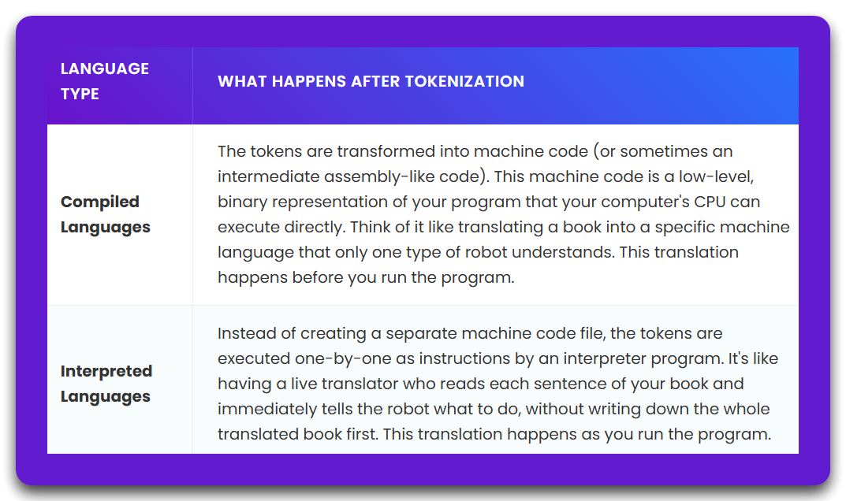
At the end, all code must become machine code.
Machine code is made of 1s and 0s.
This is the only language the CPU understands.
The machine code tells the CPU exactly what to do,
one small step at a time.

Where ASCII and Unicode Fit
Your code starts as text.
That text is saved using ASCII or Unicode.
Before the computer can understand your code:
- It reads the binary value of each character
Examples:
- i → 01101001 (ASCII 105)
- f → 01100110 (ASCII 102)
Every word, symbol, and name in your code starts as bytes.
The compiler uses these bytes to find tokens.
Short Version: From Code to CPU
- You write code in a text editor
- It is saved using ASCII or Unicode
- The compiler reads the text as bytes
- The code is split into tokens
- Tokens become machine instructions
- The CPU runs those instructions
That’s the full trip — from letters → to logic → to machine.

Machine Code Structure — Opcodes and Operands
🔧 What is machine code?
Machine code is the binary instructions the CPU runs directly.
All assembly and C code turns into machine code in the end.
Each machine instruction has two main parts:
- Opcode → what to do (like move, add, jump)
- Operands → what to use (data, registers, or memory)
The opcode tells the CPU the action.
The operands tell the CPU where and on what to do it.
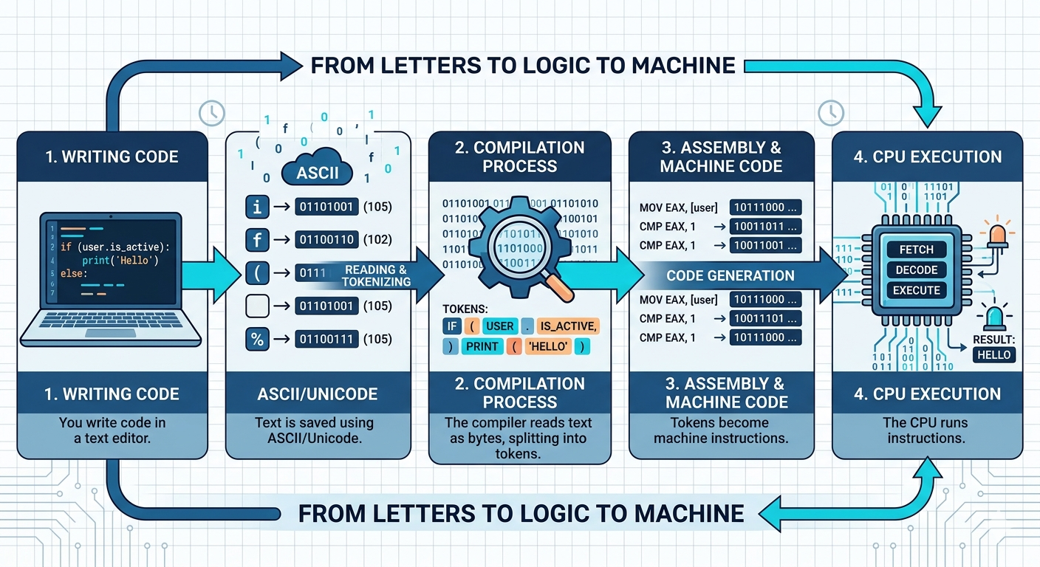
🧱 Example Breakdown:
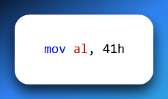
This means: “Move the value 41h (which is ASCII 'A') into the AL register.”
Let’s break that into real machine code (x86):
- Opcode for MOV AL, imm8 = B0
- Operand = 41
Final Machine Code:
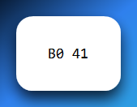
The CPU reads this as:
“Instruction B0 means: move the next byte into AL.
The next byte is 41h — which is ‘A’. Okay, done.”

🔤 2. Assembly and String Handling
I mean, In Assembly, a string is just a row of bytes in memory.
There’s nothing automatic — you work with each byte yourself.
You handle them manually, byte by byte.
💾 How to make a string:
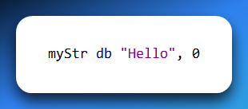
- db means “define byte”
- The 0 at the end is the null terminator (like in C)
🧪 Reading character by character:
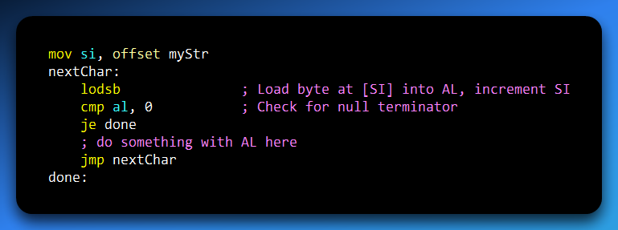
This code performs the same action as a standard 'for each' loop, but it operates at a much lower, more fundamental level of the computer's hardware.

3. Memory and ASCII/Unicode Storage
Let’s say you store the word "Hi" in memory.
ASCII:
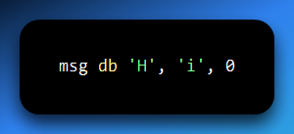
Memory layout (byte by byte):
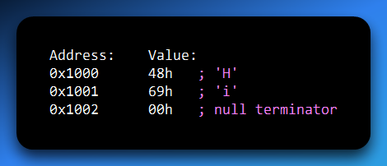
The CPU doesn’t see characters — it just sees:
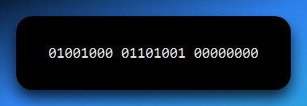

Unicode (UTF-16):
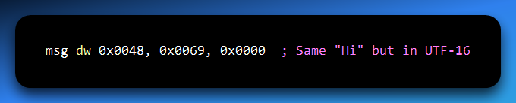
Now every character is 2 bytes:
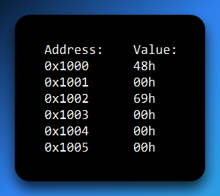
That’s why UTF-8 is more compact — it uses just as many bytes as needed.

Key Takeaways:
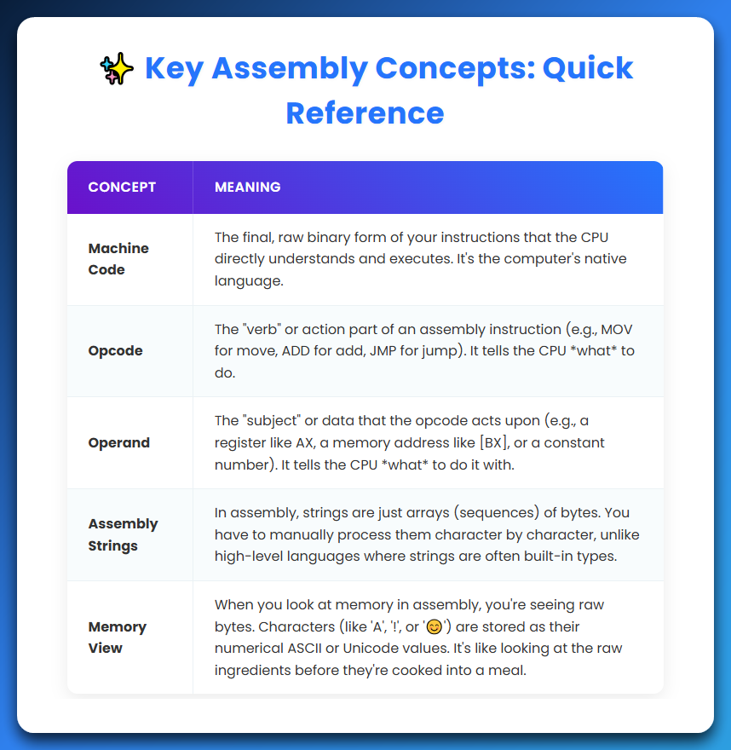

The Unicode Expansion: Encoding the World’s Language
Let’s go back to the start of our journey, from letters to logic.
Your source code (what you type) is saved using an encoding standard.

We first looked at ASCII.
- ASCII (The Simple System)
- ASCII is simple.
- It uses 7 bits.
- It can represent 128 characters.
- It works well for basic English text.
- But it has limits.
It cannot handle:
- Letters like ä
- Symbols like ¥
- Languages like Japanese or Chinese
So, ASCII is too small for the real world.

Unicode (The Big System)
Unicode solves this problem.
Unicode is like a huge dictionary of all characters.
It includes:
- All languages
- Symbols
- Emojis
ASCII is a small vocabulary.
Unicode is a global encyclopedia.

Important Idea: Code Points vs Encoding
This is a very important idea.
Unicode does NOT store bytes directly.
Instead, it gives every character a number.
This number is called a Code Point.
Examples of Code Points
'A' → U+0041
'¥' → U+00A5
'😄' → U+1F604
These are just numbers.
They are NOT stored in memory yet.
To store them, we must convert them into bytes.
This process is called encoding.

Encoding (Turning Numbers into Bytes)
Encoding turns a Code Point into binary data.
Different encoding systems exist.
The most common ones are:
- UTF-8
- UTF-16
- UTF-16 (A Smart Strategy)

UTF-16 MEANS UNICODE TRANSFORMATION FORMAT (16-BIT)
It is a variable-length encoding.
This means:
- Some characters use 2 bytes
- Some characters use 4 bytes
1. The 2-Byte Zone (Basic Multilingual Plane - BMP)
Many common characters use 2 bytes.
This area is called the BMP.
It includes:
- English letters
- Greek letters
- Arabic
- Chinese (most common ones)
- Symbols
A 16-bit number can store values from 0 to 65,535

Examples (2-Byte UTF-16)
Yen symbol (¥)
- Code Point: U+00A5
- Stored as: 0000 0000 1010 0101 (Hex: 00 A5)
Greek Lambda (λ)
- Code Point: U+03BB
- Stored as: 0000 0011 1011 1011 (Hex: 03 BB)
For these characters: UTF-16 is simple
The Code Point = the stored value

2. The 4-Byte Zone (Surrogate Pairs)
Some characters are too large for 16 bits.
Their Code Points are bigger than 0xFFFF. Examples:
- Emojis
- Ancient scripts
- Rare symbols
Problem - 16 bits is not enough.
Solution: Surrogate Pairs
UTF-16 uses two 16-bit values together.
These are called:
- High Surrogate
- Low Surrogate
Together, they represent ONE character.
Example (Emoji 😄)
Code Point: U+1F604
Stored as:
- High Surrogate: 0xD83D (1101 1000 0011 1101)
- Low Surrogate: 0xDE04 (1101 1110 0000 0100)
The system reads the first part.
It knows: “This is a high surrogate.”
It must read the next 2 bytes.
Then it combines both parts.
It rebuilds the original Code Point.
This one character now uses 4 bytes.

Why This Matters in Assembly Language
In Assembly, strings are not simple. You cannot treat a string as just a list of characters. What looks like text to a human is actually raw bytes in memory, and those bytes do not always represent characters in a consistent way.
In the ASCII case, things are very easy. Each character uses exactly one byte, so moving through a string is simple and predictable. If you want to go to the next character, you just move forward by one byte. An instruction like INC EBX works perfectly because every step lands exactly on the next character.
UTF-16 changes this completely. Characters are no longer the same size. A simple letter like 'f' takes 2 bytes, but a character like the emoji '😄' takes 4 bytes. This means you can no longer move through the string blindly, because you do not know how many bytes the next character will use.
To handle this correctly, your code must read the first 2 bytes and check what kind of value it is. If it is a normal value, then you are looking at a complete character and you move forward by 2 bytes. But if it falls into the surrogate range, then it is only half of a character. In that case, you must read the next 2 bytes as well and combine them to form the full character.
If you ignore this and just move forward without checking, you will split a surrogate pair in half. When that happens, the string becomes corrupted and the output turns into garbage, because the data no longer represents valid characters.
High-level languages hide all of this complexity. In a language like Python, strings look simple and safe to use. But in Assembly, nothing is hidden. Every character has a real cost in memory, and every byte must be handled correctly.
Looking at the bigger picture, Unicode is not just an encoding system. It is a complete system for representing text in computers. It defines code points, which are numbers for characters, and it provides encoding formats like UTF-8, UTF-16, and UTF-32 to store those numbers in memory. It also includes rules for combining characters and supports all human languages.
Unicode is what connects human language to machine memory. It acts as the bridge between what we read and what the computer actually stores.

